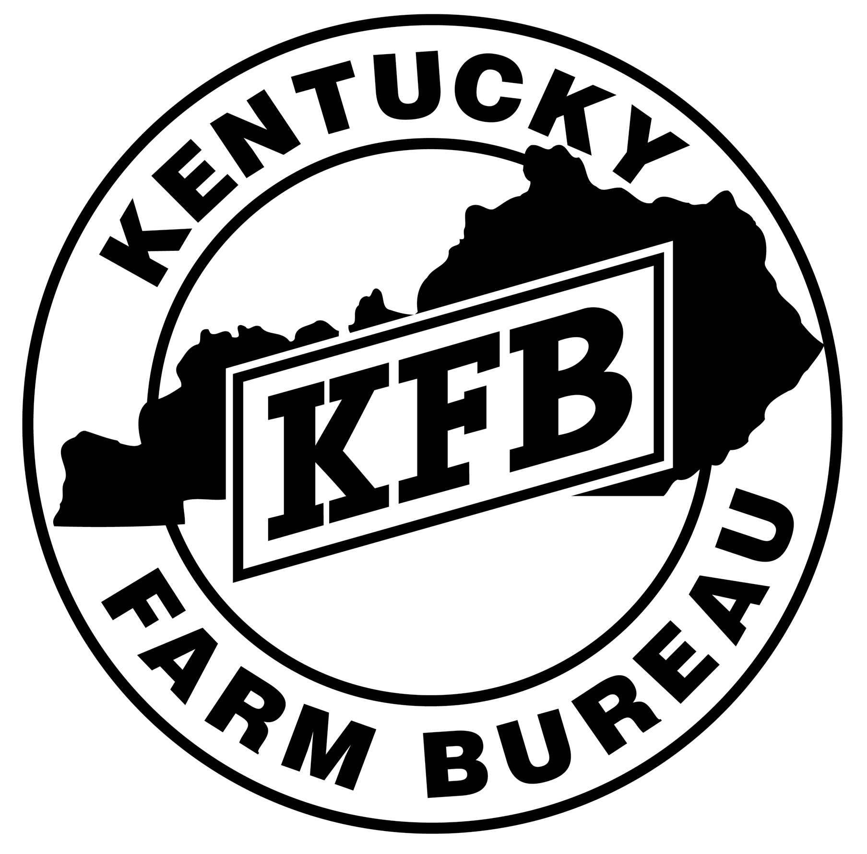2018
KENTUCKY FARM BUREAU YOUNG FARMER
SCHOLARSHIP APPLICATION

The Kentucky Farm Bureau Education Foundation will award one $2,000 college scholarship and one $1,000 college scholarship for the 2018-2019 school year. Scholarship monies can be applied to tuition, housing, books, etc. Payments are made directly to the Kentucky college or university of your choice.

To be eligible, applicants must:
- be a member of Kentucky Farm Bureau and remain such while the scholarship is in force.
Note: Applicants are strongly encouraged to retain their own membership. However, an applicant who is a dependent may apply under a parent’s/guardian’s membership.
- be between the ages of 18-35 years old. Applicants must be at least 18 years old at the time of application submission and have not reached their 36th birthday by January 1, 2019.
- be a college upperclassman (Sophomore-Senior status) for the 2018-2019 school year. Vocational/Technical school students and Graduate-level students are also eligible to apply.
- be majoring in agriculture or a related field at a Kentucky college or university, unless the program of study is not offered in the state of Kentucky.
- be enrolled as a full-time student each semester the scholarship payments are made; the student will forfeit the scholarship, should they be less than full-time.

RULES
- Dropping out of school, except for serious illness or injury, shall cause the recipient to lose the scholarship. The remaining award will then go to the first alternate.
- Winner must be a full-time student each semester unless an exception is requested in writing and approved. The winner is required to annually furnish a transcript before additional monies are sent to the college/university.
- Prior recipients of the Young Farmer Scholarship are ineligible to apply.
- Student must maintain a cumulative GPA of at least a 2.5 each semester or forfeit the award.
- The awards committee will make the final determination on all cases concerning the interpretation of these rules. All applications become the property of the Kentucky Farm Bureau Education Foundation and will not be returned.
All application materials must be postmarked by April 28, 2018. No applications will be accepted after this date. Completed applications may be hand-delivered or mailed to:

Kentucky Farm Bureau Education Foundation, 9201 Bunsen Parkway, PO Box 20700, Louisville, KY 40250-0700

STUDENT INFORMATION
Please print or type all information on this application. Attached sheets may be typed.

Name____________________________________________________________________________________________
(First) (Middle) (Last)

Address___________________________________________________________ Phone (_____)_________________
(Street or Route) (City/State) (Zip Code)

E-Mail___________________________________________________Membership County ________________________

Date of Birth ___________________ Age _________ Sex _______ Farm Bureau Membership # __________________

College/University You Are Attending ___________________________________________________________________

Major ______________________________________________________________ Minor ________________________

Career Choice ___________________________________________ GPA _________________ (Based on a 4.0 scale.)
PLEASE INCLUDE THE FOLLOWING:

- An official transcript of your grades.
- Letters of recommendation describing characteristics such as leadership, citizenship, responsibility and potential. Two (2) are required; one must be from a college professor/instructor and one from a non-relative.
- An essay, in 300 words or less, answering the question, “What is my role in the future of agriculture?”
- An additional essay, in 300 words or less, explaining “Why I am pursuing a college education”
- A one-page résumé highlighting awards, achievements, community service and extra-curricular activities. (Please attach to the following page.)

WORK EXPERIENCE
Describe jobs you hold or have held.  (Include work on family farm.) | What are/were your hours per week and for the school year? | Date of Employment  From: To:

KENTUCKY FARM BUREAU
YOUTH & YOUNG FARMER INVOLVEMENT
In the space provided, please indicate Kentucky Farm Bureau activities or programs in which you have participated, as well as the years you attended. Additional space is provided for you to include participation in other Farm Bureau-related events or activities (e.g. Futures Seminar, Beef Tour, etc.).

Example: ☑ Outstanding Farm Bureau Youth Contest (Years) 2015, 2016, 2017

❒ Student Agriculture Science Exhibit (Years)___________________________________

❒ Outstanding Farm Bureau Youth Contest (Years)___________________________________

❒ Variety Contest (Years)___________________________________

❒ Institute for Future Agricultural Leaders (Years)___________________________________

❒ Young Farmer Leadership Conference (Years)___________________________________

❒ Young Farmer Summer Outing (Years)___________________________________

❒ Kentucky Farm Bureau State Annual Meeting (Years)___________________________________

❒ KFB Event:_____________________________ (Years)___________________________________

❒ KFB Event:_____________________________ (Years)___________________________________

❒ KFB Event:_____________________________ (Years)___________________________________

❒ KFB Event:_____________________________ (Years)___________________________________
In this space, please attach a one-page résumé highlighting awards, achievements, community service and extra-curricular activities.

FINANCIAL NEED ASSESSMENT
In the following space, please provide an estimate of how much money may be available to you for the 2018-2019 school year from each of the following sources. If you are receiving multiple scholarships, please list each of them by name in the space below.

Scholarship # 1 _____________________ $________________________________________

Scholarship # 2 _____________________ $________________________________________

Scholarship # 3 _____________________ $________________________________________

Scholarship # 4 _____________________ $________________________________________

Scholarship # 5 _____________________ $________________________________________

Personal Savings or Job $________________________________________

Parents $________________________________________

Other Sources (list each source)

__________________________________ $________________________________________

__________________________________ $________________________________________

__________________________________ $________________________________________

__________________________________ $________________________________________

__________________________________ $________________________________________

Total $________________________________________

APPLICATION POSTMARK DEADLINE: April 28, 2018

About the Kentucky Farm Bureau Young Farmer Scholarship…
Monies for the Kentucky Farm Bureau Young Farmer Scholarship have been raised through the leadership of the Kentucky Farm Bureau Young Farmer Advisory Committee. County Young Farmer committees, with the support of their county boards, participated in an auction at the 2014 Kentucky Farm Bureau Young Farmer Leadership Conference and raised more than $5,800 for this scholarship program. The Kentucky Farm Bureau Education Foundation administers this scholarship and will annually award one $2,000 scholarship and one $1,000 scholarship to qualified young farmer recipients.

Please note the following…
The Young Farmer Scholarship recipients will be notified by May 18, 2018. The recipients will be required to attend the scholarship awards presentation which will be held at the 2018 Kentucky Farm Bureau Young Farmer Summer Outing in Lexington, KY.

(REV 1/18)

